**Sample 1**

**Short Description:** **X files are older than lower limit xx in directory D:/Products/WERUM/PasxClient/INOVAWXI/WXI/ messages/mess_out**

A. on server (of alarm) :

Restart WXI Client only :

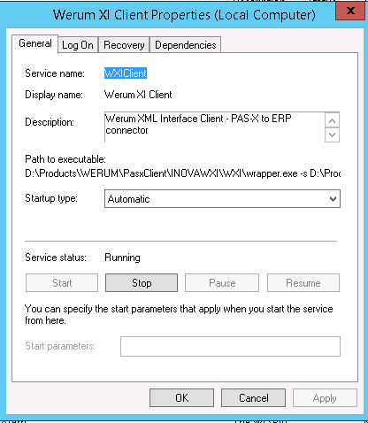

B. Notify this issue by an email  to MES_INOVA_SUPPORT <MES_INOVA_SUPPORT@emailph4.aventis.com>

C. Assign the ticket to the applicative support group

Search  ("DiaMS Support group") on <http://communitiesemea.sanofi.com/isia/IN/sso/Lists/ITSIISALLApplications%20List1/AllItems.aspx?View=%7BFF460492%2DE875%2D4142%2D9BBB%2DD8F7505D4FE9%7D&ShowInGrid=HTML&InitialTabId=Ribbon%2EList&VisibilityContext=WSSTabPersistence>

D. End

**Sample 2**

**Short Description: UNX02 | CPU % CPU Utilization > 99% for 10 min**

Issue:  CPU > 99%

Root cause: This is a development server with low configuration and spikes are observed for few minutes during extensive workload on the server

Solution: Informed the ACI Project team to pay attention to server CPU usage

**Sample 3**

**Short Description: SHAREPOINT - security group creation issue**

**Question:**

user asked to create SharePoint “Security Group"?

**Answer:**

on the very first place we have to check whether user want to create security group for distribution list or not.  
if user wants security group to be created to the respective distribution list then we have to identify first the region user belongs to.  
if distribution list is not given in the incident then ask user for the same.  
sometimes we are not able to find the POC for respective region, in this case we need to coordinate with Onsite Coordinators.  
  
Reference Incident Number:-INC000007275361 /INC000008111314

**Technician Notes:**

**Sample 4**

**Short Description: [ELSE] - ELSE - Open Lab ELN - Insertion issue - Picture insertion issue**

Question:

When I Copy/Paste a picture file into ELSE, it is not working.

Answer:

|  |  |
| --- | --- |
|  |  |

[ELSE - Open Lab ELN - Insertion issue or PDF rendition issue - Picture insertion issue](http://wiki.pasteur.aventis.com/confluence/display/ISRDBAS/ELSE+-+OpenLab+ELN+-+Insertion+issue+or+PDF+rendition+issue+-+Picture+insertion+issue)

|  |  |
| --- | --- |
| Solution Code | ELSE |
| Title | Picture insertion issue |
| ARS Reference | ... |

Description

When I Copy/Paste a picture file into ELSE, it is not working.

Or error message ‘java heap space’ when insertion of an image document:   
  
Or the PDF rendition is not working => it could be identified during the signature workflow. 

Link to Incident in Remedy

INC000003533490

Solution

The copy/pase or the Drag&Drop don't work for the picture file formats (jpg, gif, png ...)

To insert a picture into ELSE you must:

* either use the icon 'Insert File (Link, Image, Object ...)'
* either open the file in an image editor (MS Paint ...) or in Word, select the image and make a copy the insert button and then paste the file in the ELN.

Note: some picture formats are not authorized into ELN (eg .bmp)

Technician Notes:

<http://wiki.pasteur.aventis.com/confluence/display/ISRDBAS/ELSE+-+OpenLab+ELN+-+Insertion+issue+or+PDF+rendition+issue+-+Picture+insertion+issue>

**Sample 5**

**Short Description: [LEARN] - LEARN- User not present in LEARN**

Question:

User don’t have access to LEARN

Answer:

If user is not present in LEARN ,We need his TA/PA or Manager approval to add him to LEARN   
Please send below mail to user in such cases   
  
We check your account is not available in  LEARN.   
[All access requests must be initiated by a LEARN People Administrator, please c](mailto:Le@rn)[ontact a local LEARN People Administrator or your functional representative from the LEARN Expert User Team (EUT). If you do not have a functional administrator, please contact an EUT representative from Quality Operations.](http://scientifique-ar.sanofi-aventis.com/IS/Pages/en/Learn/learn_EUT_en.htm)  
This is about your access request to the LEARN Platform and is designed to help you for your request:   
1)      Who is allowed to request:   
Customers cannot request to their access on the LEARN Platform directly. Only Local LEARN People Administrators (PA) are allowed to request for an access. The list of PA is available at: Link to the list of PA  
If there is no Local LEARN People Administrators in your organization, then this is your Manager/Supervisor who is allowed to request for your access.   
2)      How to request access:   
The PA or the Manager/Supervisor has to provide to the Service Desk a Full filled LEARN Access Request Wizard:

* Please raise request using the below link : <https://sanofiservices.service-now.com/onesupport/?id=request_order&sys_id=0a9b19f2dbe18fc405ea766eaf961978>